## ASSIGNMENT

Name :- mylarapu Ravi

Batch :- 119

Ph.no :- 6302540471

E-mail :- [ravimylarapu39@gmail.com](mailto:ravimylarapu39@gmail.com)

Assignment :-create a vpc attach lambda and attach data base to lambda

1.first create Iam role and lambda permissions and database permissions and vpc full access can be allowed 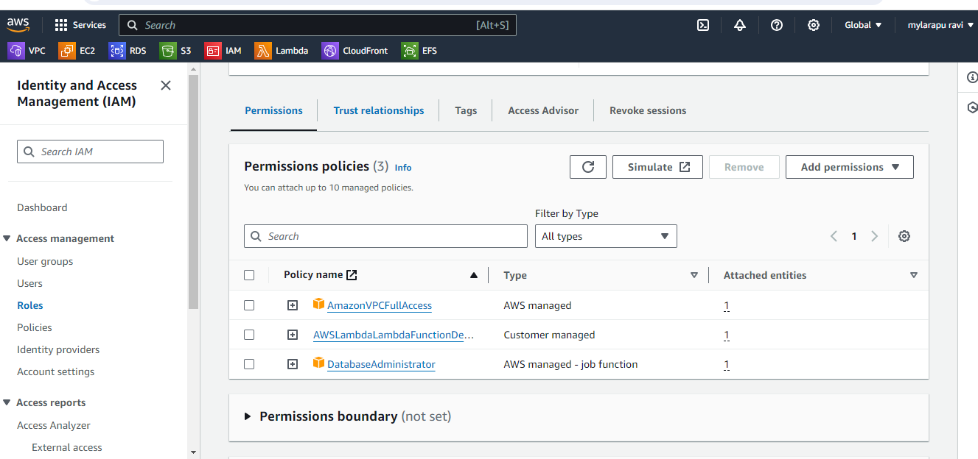

2.next create lambda function and select python 3.12 and select exicting role option. 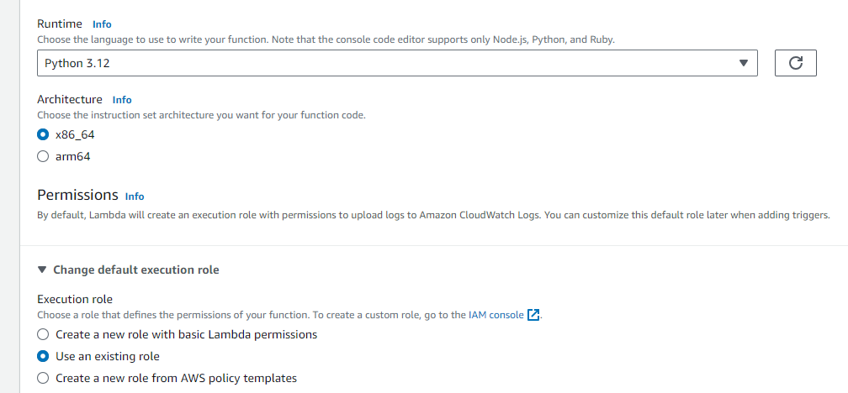

3.next click the advanced settings and select the enable vpc option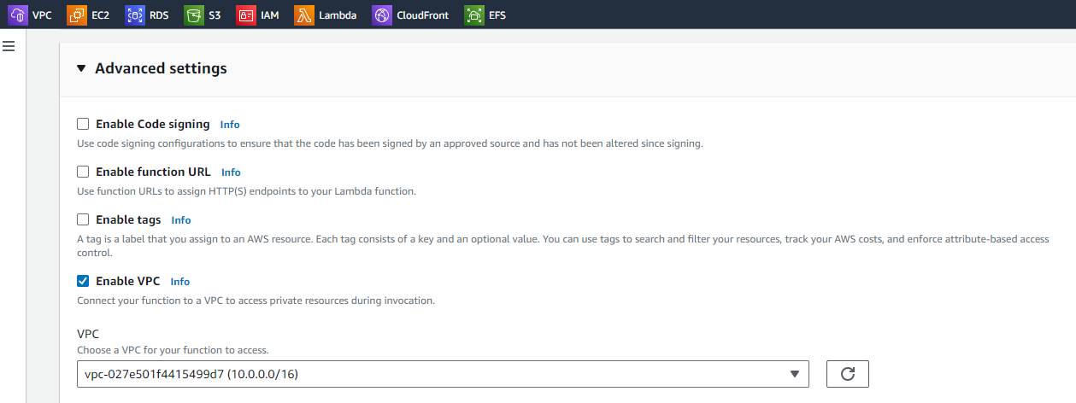

4.next select atleast one subnet already existing subnets and select your security groups 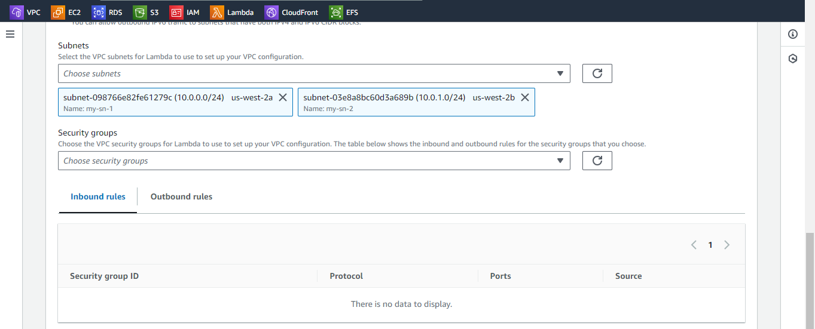

5.next add trigger api gateway .lambda function overview

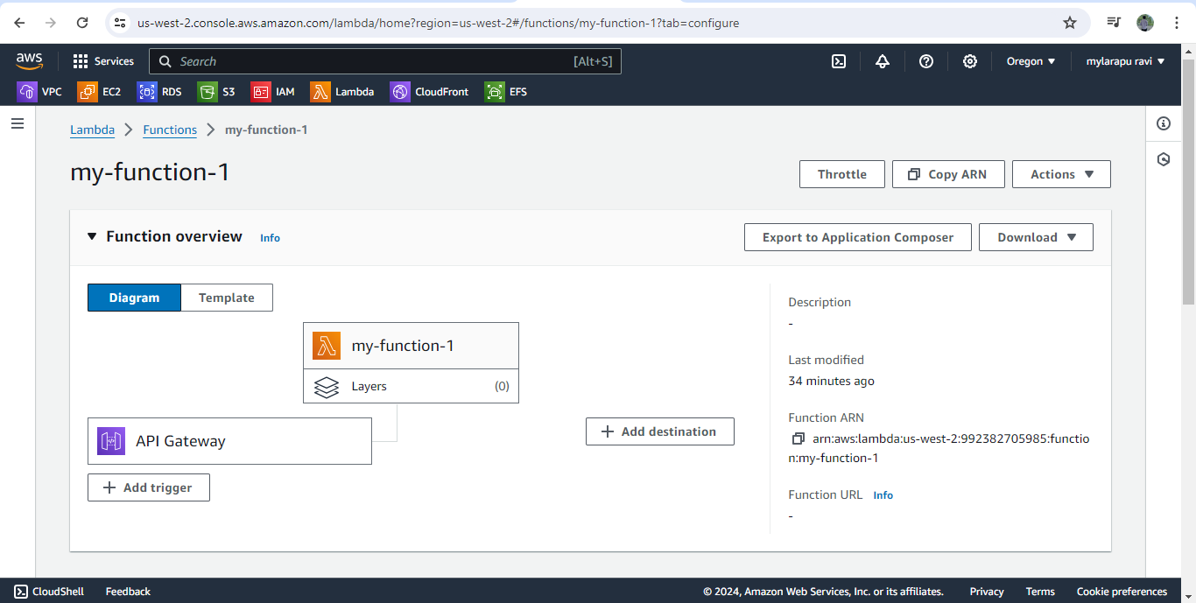

6.in lambda function vpc details 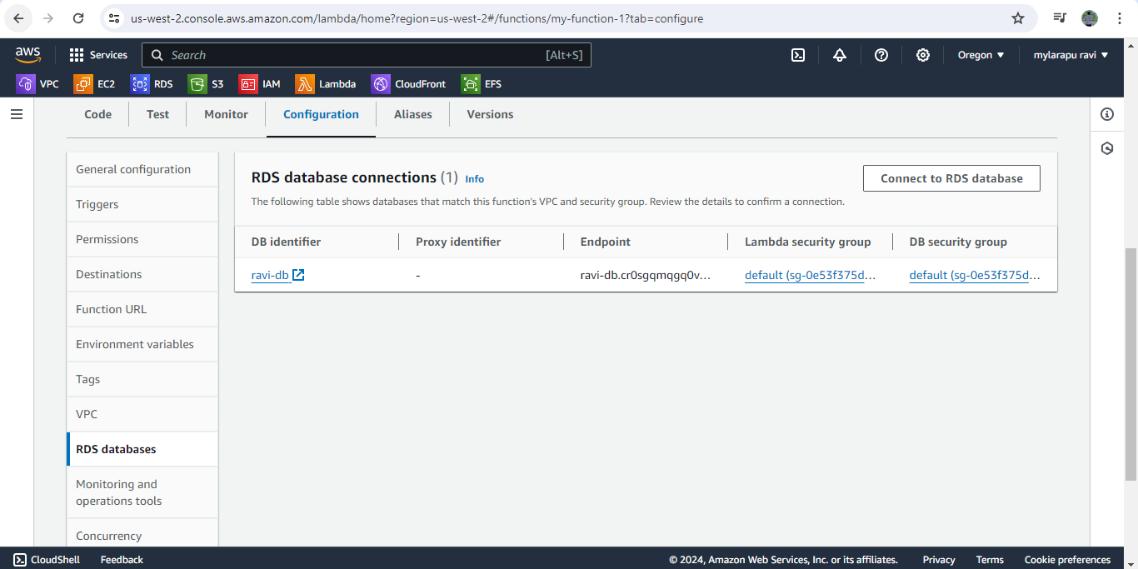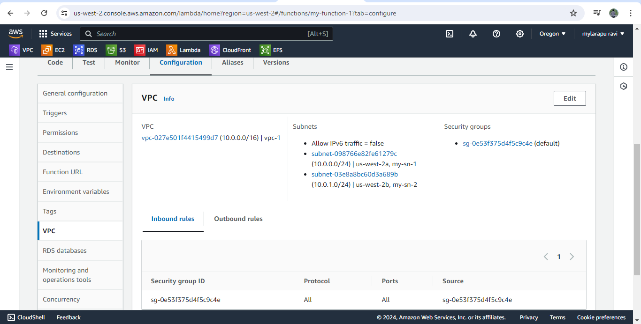

7.next create database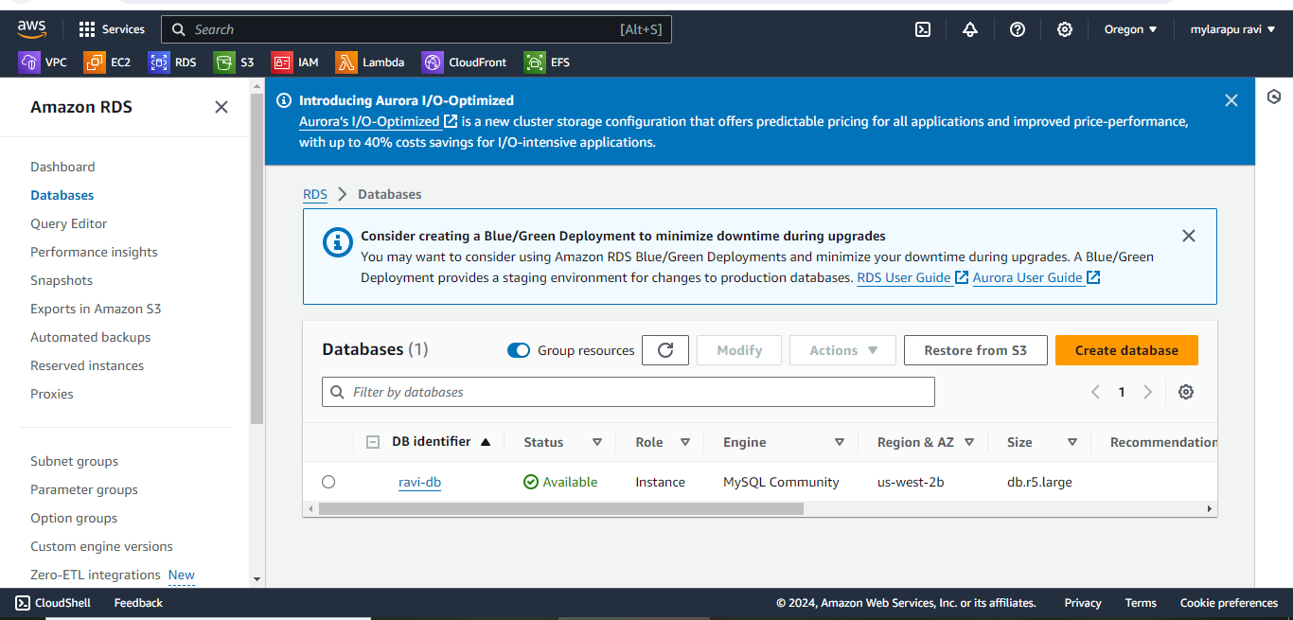

8. next connect database 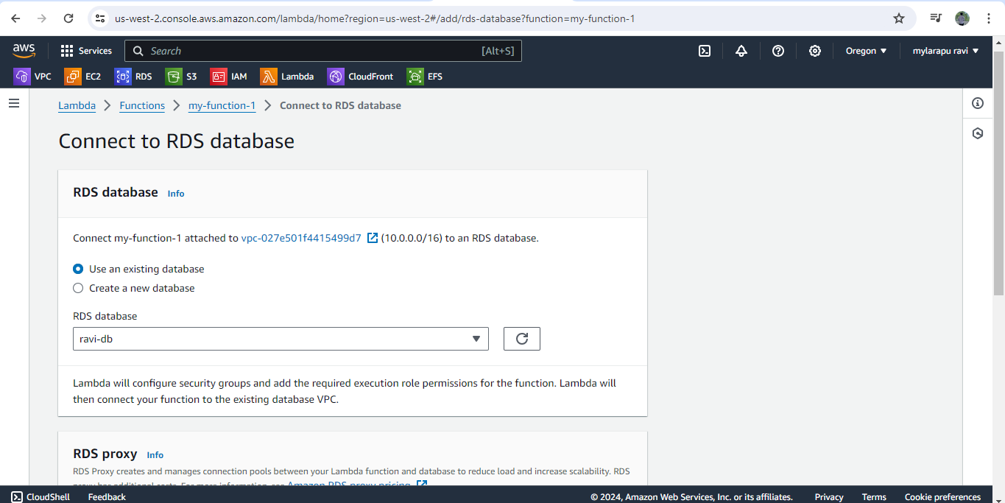

9.finally rds database connections 